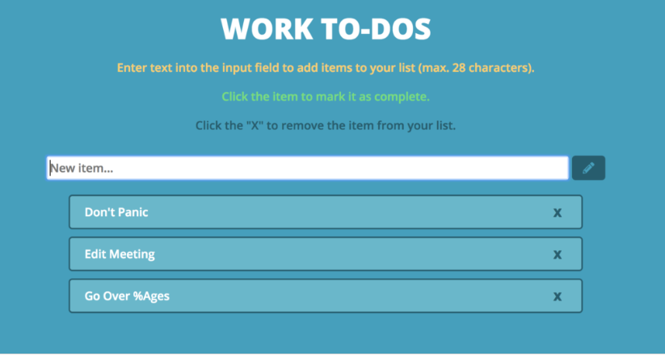

You have to create a simple to-do management application like above, but you don’t have to exactly replicate the styles.

**Validations**

1. User shouldn't be able to add empty to-do item
2. User shouldn't be able to edit item and save as empty
3. User shouldn't be able to add a duplicate to-do item

**Requirements:**

1. User can a new to-do item in the list
2. User can edit existing to-do
3. User can delete any item from to-do list
4. User can drag and drop items in the list to change the priority (Bonus Task)
5. User should be able to select multiple and delete them
6. Also can you add the functionality for marking the item as done or pending and change the colors of items depending upon the status
7. Also create 2 lists for items, 1st for pending and 2nd for done which should be separated.

**Deliverables:** Code should be clean and understandable; you can use comments where you think it’s necessary. You have to complete this task by EOD of Wednesday